Some of the common file handling operations are;

1. Create file
2. Delete file
3. Read file
4. Write file
5. **Create file :**

**Way 1 :** Use File.createNewFile() method to create a file. This method returns a boolean value : **true** if the file is created successfully; **false** if the file is already exists or the operation failed for some reason.

**File Creation :**

**public** **static** **void** main(String[] args) {

**try** {

// Creating an object of a file

File myObj = **new** File("C://Users//ppp.txt");

myObj.createNewFile();// Creating new file here

System.***out***.println("File created: " + myObj.getName());

}

**catch** (IOException e) {

System.***out***.println("An error occurred.");

e.printStackTrace();

}

}

Way 2**:** FileOutputStream.write() method automatically create a new file and write content to it. Eclipse : fileDemo1

Way 3: String data = "Test data";

Files.write(Paths.get("c://temp//testFile3.txt"), data.getBytes());

1. **Write to file :**

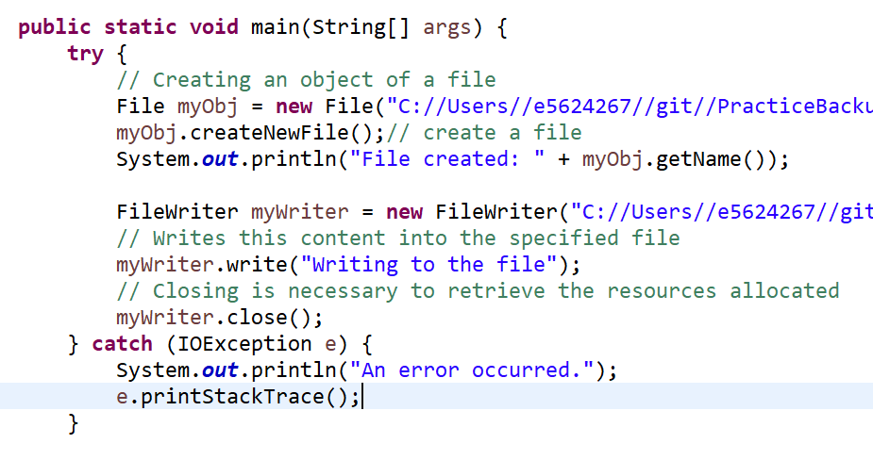

1. **Read file data :**

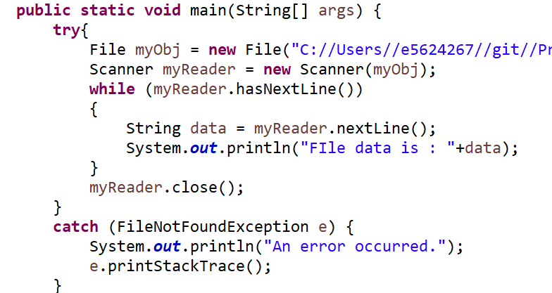

**Read from file :**

1. There are many ways to read a file, but this BufferedReader is the simplest and most common-used method.
2. Using FileReader class as well we can read it.
3. **Delete file :**

